***Nuffield Road Medical Centre***

***Patient Booklet***

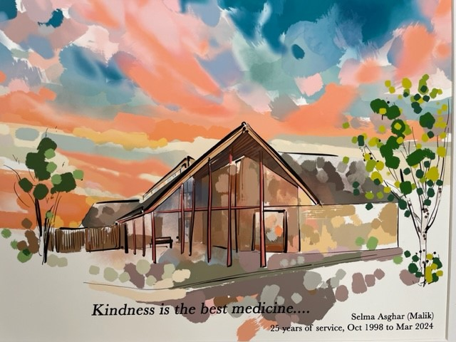

ROAD MEDICAL CENTER.

Nuffield Road Medical Centre

10 Pippin Drive

Cambridge  
 Cambridgeshire  
 CB4 1GL

Telephone - 01223 423424

Website - [www.nrmc.nhs.uk/homepage](http://www.nrmc.nhs.uk/homepage)

**Welcome**

**Welcome to Nuffield Road Medical Centre.**

The Partners and team would like to welcome you to Nuffield Road Medical Centre. We hope you find lots of useful information about the surgery and the services we offer on our website and this introductory guide.

Our aim is to provide excellent and high quality personal care to all our patients, whilst respecting confidentiality and patient dignity. We strive to deliver a professional patient focused service and always encourage patients to be involved in the planning and maintenance of their own health and well-being.

We are a friendly team with 24 clinical staff and an experienced team of support staff.

By joining Nuffield Road Medical Centre, you have agreed to work in partnership with us as your NHS health care provider. The success of our partnership relies on both parties understanding the needs of each other, maintaining good co-operation and communication.

Our responsibility to you:

* You will be treated with dignity and respect at all times
* You have the right to confidentiality
* You have the right to access your medical records, subject to the limitation of the law
* You will receive the results of any tests or investigations once we have them
* Your suggestions, concerns, complaints and compliments will be welcomed and used where possible to drive improvement

Your responsibility to us:

* We expect all staff to be treated with the same respect you would want to receive from us. We have a zero tolerance policy with regards to abuse.
* You will inform us if you are unable to attend an appointment
* You will inform us of any changes to your personal details, including a change of address

When booking an appointment at the surgery, you will be directed to the most appropriate clinician; this may not be a GP. We ask that you provide our support team with sufficient information to enable them to direct you appropriately. Unfortunately due to the ongoing underfunding in the NHS, at this time it is not possible for everyone to see a GP. All our clinicians are experienced. Thank you for your understanding.

We hope you find the booklet helpful. If you need anything further, please do not hesitate to ask a member of the team. Once, again, your feedback is welcome.

Best wishes, The Partners and Practice Manager, Nuffield Road Medical Centre

**Contents**

Welcome Page 2

Kindness is the best medicine Page 3

About our team Page 5

Registering at the surgery Page 7

Registering at the surgery – out of area Page 7

New baby registrations Page 8

Change of details Page 8

Booking appointments Page 9

Attending appointments Page 9

Extended hours appointments Page 9

Home visit Page 10

Waiting list Page 10

Cancelling an appointment Page 10

Blood results / test results  Page 10

Administration / Prescriptions other queries Page 11

Access to your medical record Page 12

Proxy access (giving access to your medical record) Page 12

Prescription requests Page 13

Electronic prescriptions Page 14

Medications not on repeat prescription Page 15

Medication reviews Page 15

Electronic repeat dispensing Page 15

Medications no longer available on the NHS Page 15

Appointments – Long Term Condition Reviews Page 16

6-8 week baby checks and post-natal appointments Page 16

Chaperone Page 17

Referrals to other services Page 18

Self Referral Services Page 19

Non-NHS work Page 20

Letters and fees Page 21

Registering a death Page 22

Respect and behavior  Page 24

Compliments, Feedback and Complaints Page 24

When the surgery is closed Page 25

**Kindness is the best medicine …**

The practice serves the area in Cambridge City lying to the North and West of the river and the villages of Histon, Impington and Milton. Our practice area is available here:

<https://www.nrmc.nhs.uk/register-at-the-practice>

We welcome you choosing Nuffield Road Medical Centre to support you with your health needs.

We ask that everyone is treated with respect. We do not tolerate any aggressive, violent or discriminatory behavior towards our team. We have a zero-tolerance of behavior of this nature. The practice will use its right to remove patients from our list with immediate effect, to safeguard the team, patients and other members of the public.

**About our team**

**Our Practice Manager is Samantha Sales.**

**Samantha can be contacted at cpicb.nrmcpatients@nhs.net**

|  |
| --- |
| **GP Partners at the practice are:**  Dr Mark Brookes Dr Sarayu Nair  Dr Annabel Wood Dr Katherine Wyatt |

**Registrars**

Emily Robinson

Rahul Vyas – Clinical Pharmacist

James Gatton – First Contact Practitioner

**Advanced Care Team**

Michael Leary – Advanced Care Practitioner

Dharamendra Nortam – Emergency Care Practitioner

Lydia Chinyere – Advanced Nurse Practitioner (Diabetes)

Kat Burrell – Advanced Nurse Practitioner (Respiratory)

**Doctors**

Dr Claire Charlesworth

Dr Paula Garzon

Dr Vikki Hobbs

Dr Samira Hoque

Dr Nadia Jawed

Dr Christine Kerr

Dr Yen Xuan Nguyen

Dr Keiko Verzon (on maternity leave)

**Nursing / Health Care Assistant (HCA) Team**

Lead Nurse – Sarah Vatcher HCA – Mandy Burling

Nurse – Swati Jain HCA – Glenda Campbell

Nurse – Leigh-Ann Jennings HCA – Marie Gilbert

Nurse – Callie Hewkin

Sofia Regitsa – Social Prescriber Gemma Blackford – Social Prescriber

**The team are supported by a skilled support team. These roles include reception, administration, prescription clerks and care co-ordinators.**

**We have a multi-disciplinary team to support our patients.**

**Advanced Nurse Practitioner -** Fully qualified who deal with minor illnesses

**Emergency Care Practitioner –** Trained in nursing and paramedic skills. Work alongside our clinical team to help manage routine and urgent appointments, and attends home visits.

**First Contact Practitioner (FCP) -** First contact practitioners in primary care are to assess patients with muscle, soft tissues and joint pain to help decide on the most appropriate management, for example;

All soft tissue, sprains, strains or sports injuries.

Arthritis – any joint

Spinal related pain in arms or legs. Nerve pain such as pins and needles or numbness.

Spinal pain including lower back/ mid back and neck pain.

Please note FCP’s cannot see anyone under the age of 16, or someone who needs medical management of rheumatoid conditions or house-bound patients.

**Health Care Assistants** can offer

Long term pre-checks Blood testing ECG

Blood pressure check New patient check Weight checks

If a child is needing a blood test and they are under the age of 10, you will need to collect a blood form from the GP or Receptionist and attend an appointment at the hospital.

**Nurses** can offer

Cervical smear screening Smoking cessation Diabetic clinic

Baby & child immunisations Minor injury check Contraception pill review

Travel advice & immunisations

**Social Prescriber -** We have a social prescriber who is here to help with any worries or advise with regards to financial issues, letter requests, help with wanting to join social groups etc.

**New Patient Registrations**

If you live within our practice area and wish to register with us, you can register online or using the new registration forms.

Using our online form is the quickest and easiest way to register with the surgery. If you use the online link below, registration is usually completed within 2 working days. To do this, please use this link: <https://register-with-gp.ht1.uk/?gpCode=D81044&gpName=Nuffield%20Road%20Medical%20Centre>

**How to Register at the Practice**

If you prefer to use the paper forms, these can be found on our website using the following link: <https://www.nrmc.nhs.uk/register-at-the-practice>

If you complete the paper form, registration will be completed within 7 working days.

The forms can also be collected from the reception.

When we receive your registration you will be asked to a new patient health check with a Health Care Assistant. We encourage all our new patients to attend this appointment.

Once we have accepted your registration your medical records will be transferred to the practice.

**Out of Area Registrations**

If you live outside of the practice area we are unable to accept a registration.

If you change your address to outside of our practice area you will be asked to re-register at a surgery closer to your new home. You will be given 30 days to do this. After this time you will be taken off the register at the surgery.

**New Baby Registrations**

We encourage you to register your baby with a GP as soon as possible. You do not have to wait until you have registered the birth with the Registry Office. This helps in case urgent care is required and enables us to book in their 6–8-week baby check and inoculations. You will need to complete a GMS1 form and a New Patient Questionnaire. We ask that at least one parent is already registered with the surgery or registers at the same time.

**Change of Details**

If you change your address, email address, telephone number, mobile number or next of kin please inform us as soon as possible. It is important to keep your contact details up to date in case we need to contact you or a family member in an emergency.

If you wish to amend your name on your medical record, we will need to see some form of photo ID. This can be done on our website by clicking on ‘submit a new request’.

[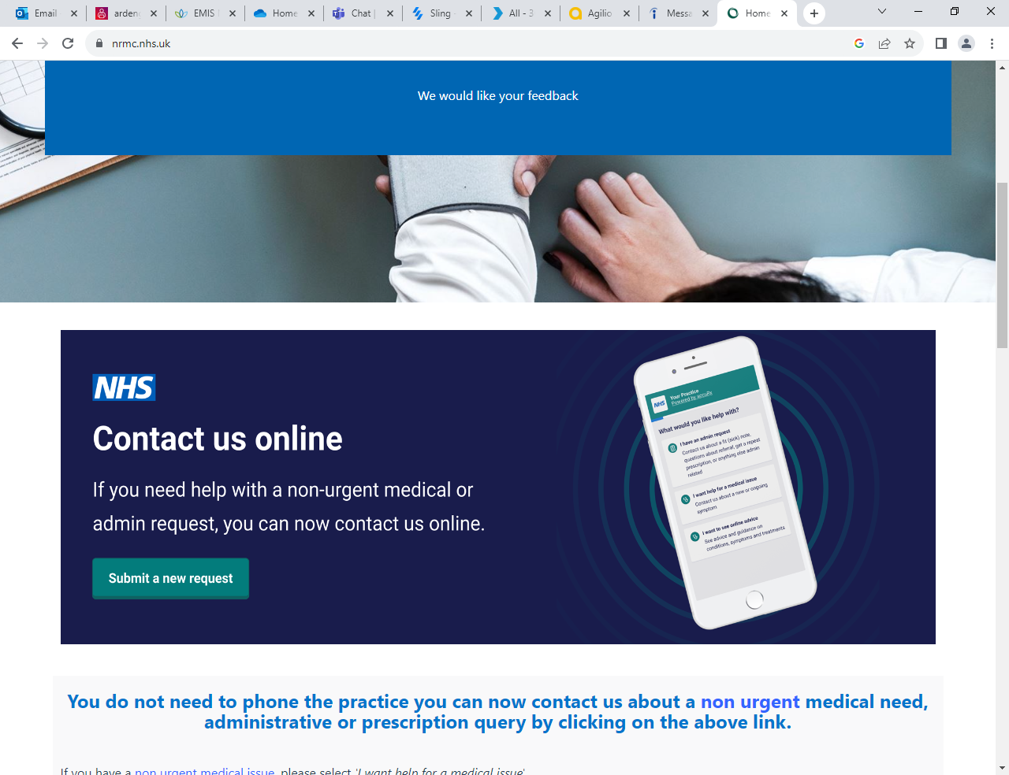](https://florey.accurx.com/p/D81044)

**Booking appointments**

Telephone - You can make an appointment by calling 01223 423424 during the hours of 8.30am until 6pm Monday to Friday. Please do not attend the surgery to make an appointment.

Automated Service – Another option features on our phone system, which allows you to book a GP consultation up to one week in advance, you can also request your repeat prescriptions using our automated system, without waiting to speak to a receptionist. All you need to do is simply press option 1. (Please ask Reception for a PIN number before using this service)

Online – You can search our website (Nuffield Road Medical Centre) on the front page there will be a link to send your appointment request to, the reception team will be in touch within 2 working days.

Call backs – Call backs is a recently new facility, call 01223 423424, press option 2. You will then be asked if you would like to request a call back. Once your call back has been logged you can hang up the phone and the system will call you back automatically once a receptionist becomes available. (You will keep your position in the queue).

We understand it is preferable for you to see your usual doctor whenever you can. However, if your problem is urgent and your doctor is not available, our reception team will explain what alternatives are available. Appointments can be booked up to 1 week ahead, however most appointments are kept for the same day.

Demand at the moment for general practice is very high, therefore we will do our best to get you seen as soon as you can. Please be kind to our team.

**Attending appointments**

We would ask patients to arrive on time to any appointment to ensure proper use of availability and resources. We offer different ways of attending an appointment with a clinician such as face to face, telephone consultations or video call.

Some times our clinicians do run late. We ask for your understanding, as our clinicians want to ensure that they give patients time that is needed. Our reception team will try and keep you updated. If you are concerned about the time you are waiting, please talk to our receptionist.

To help you get the best out of your appointment, please see our guidance on the website. Information can be found here -

**Extended hours appointments**

We do have an Extended Access service. We work in Partnership with the Cambridgeshire GP Network to provide this service. We can book these appointments and the appointments are available at the weekend and evening. They offer Clinicians, Nurses and Healthcare Assistants appointments. These appointments can be at various locations around Cambridge.

**Home Visits**

If you, the patient is housebound or request a home visit, please call the surgery. Please provide the support team with sufficient details to enable the GP to assess the urgency of the home visit. The GP will confirm a home visit and which clinician may attend. This will not be a GP.

**Waiting List**

Due to demand and funding from the NHS, we do operate a waiting list. If we do not have appointments on the day, you will be offered alternatives. This will include:

* Contacting 111 if you feel that you need medical attention earlier than we can offer
* A referral to the Pharmacy. This is known as Pharmacy First
* A referral to another organisation i.e. Healthy You, CGL

If you do not wish to accept an alternative appropriate referral, you can contact the surgery on the next working day.

**Cancelling an appointment**

Unfortunately, about 10% of our appointments are wasted every month. This is due to our patients not cancelling appointments. It is very important to inform reception as soon as possible if you are not able to attend your appointment so we can offer the appointment to another patient.

You can cancel your appointment in three ways:

1. Call our cancellation number - 01223 422545. Please leave a voicemail with your name, date of birth and the date and time of the appointment you would like to cancel.
2. If you are not able to call, then please send a message on our website using the following link - <https://florey.accurx.com/p/D81044>

**Blood results / test results / prescriptions and other enquiries**

To help us deal with the calls first thing in the morning for appointments, we ask that if you are calling regarding results, prescriptions, admin queries **please call after 2pm**.

Unfortunately if you do call before 2pm, we will be unable to deal with your query and you will be asked to call back after 2pm.

**Administration / Prescribing / other queries**

* **Requests using the link on our website**

You can send a message to us on our website to request a medical appointment, order medications and request admin queries; by clicking on the following:

[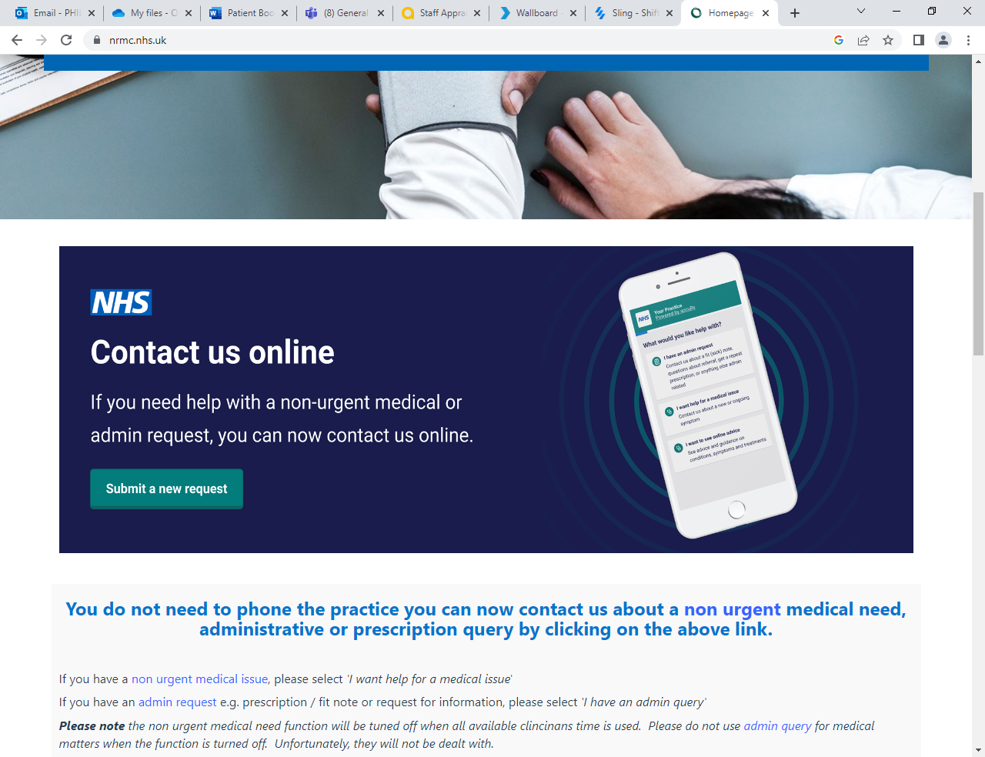](https://florey.accurx.com/p/D81044)

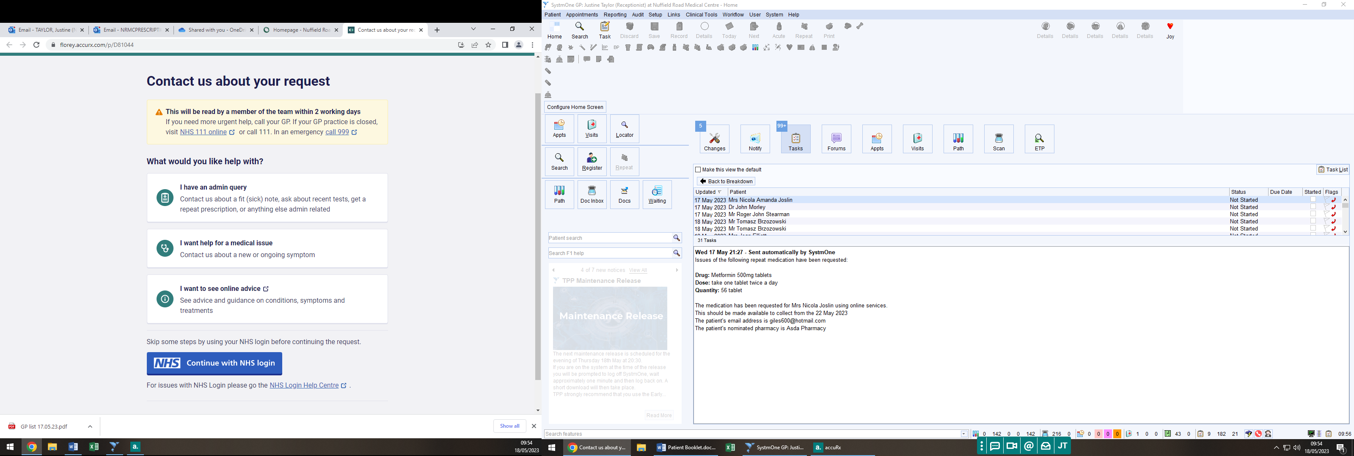

Once this has been filled out, the request will be sent to our support team, and they will contact you within 2 working days.

**Access to your medical record**

Where it is safe for you to do so, we encourage you to have access to your medical records.

The easiest way to do this is by downloading the NHS App. Once you download the NHS App, you will be able to see your medical records from that date onwards. More information about the NHS App are below.

Alternatively, you can be given access via the airmid app. More information is provided below.

The benefits of having access to your medical record are:

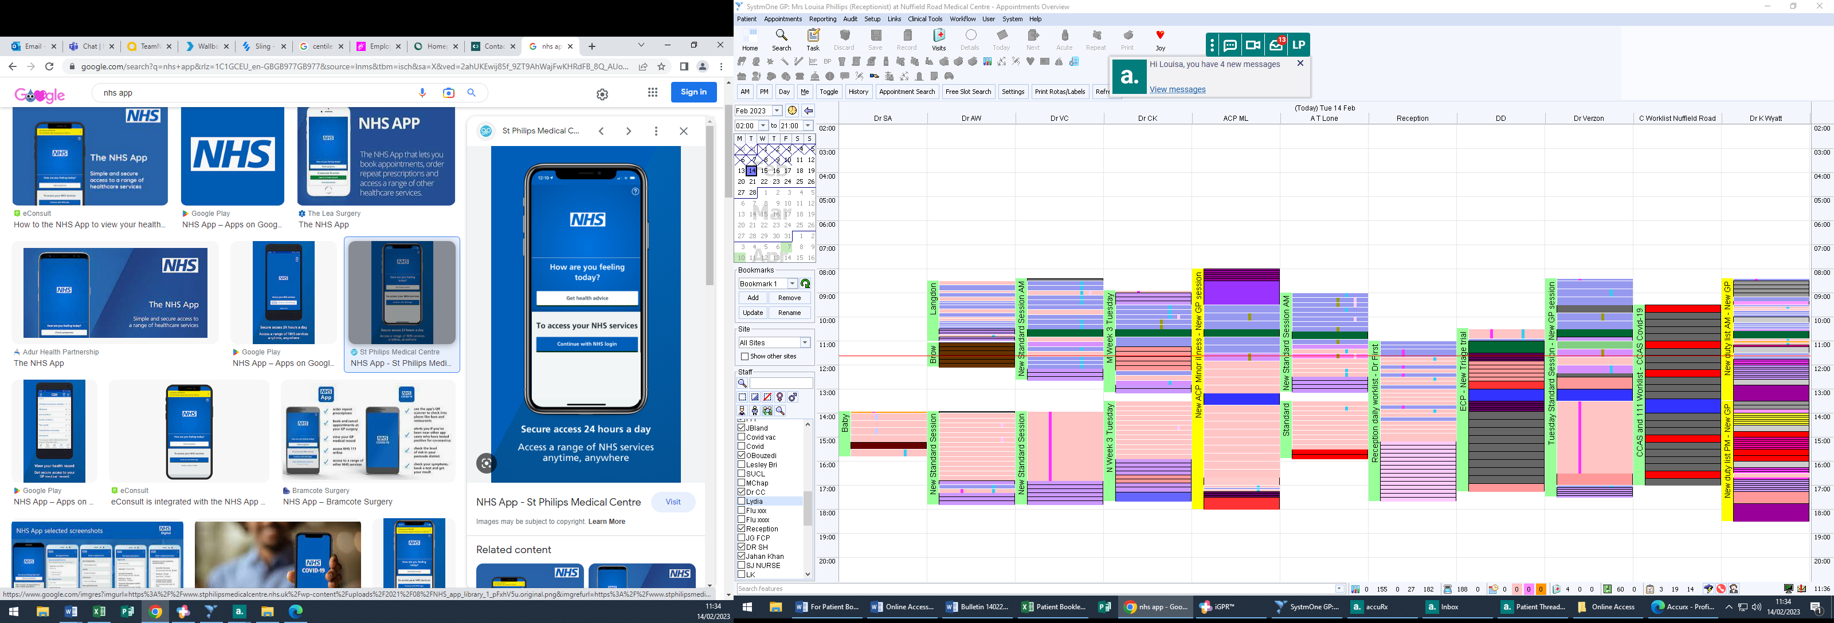On occasions, your GP may consider it unsafe for you to have access to your medical record. Should this be the case, you will have the opportunity to discuss this with the Practice Manager or your GP.

**NHS App**

You can also access your account through the NHS app. The team will need to give you full clinical access first to view your records and then once you receive that, then you can create your own account to book appointments, order medications, view your records and test results etc.

**Proxy Access**

We provide proxy online access to patients who may require their family or friends to help them order medications, book appointments and view your medical records. Also, if you have younger children, you can attach their records to yours so you can again book appointments and anything that you require.

Please click the link below to be able to register for an online proxy account:

[**PROXY ACCESS - More Information**](https://www.nhs.uk/nhs-app/nhs-app-help-and-support/linked-profiles-in-the-nhs-app/apply-to-manage-gp-services-or-get-help-managing-yours/?wt.mc_id=qr) – once you click the link, it will take you to the page shown below.

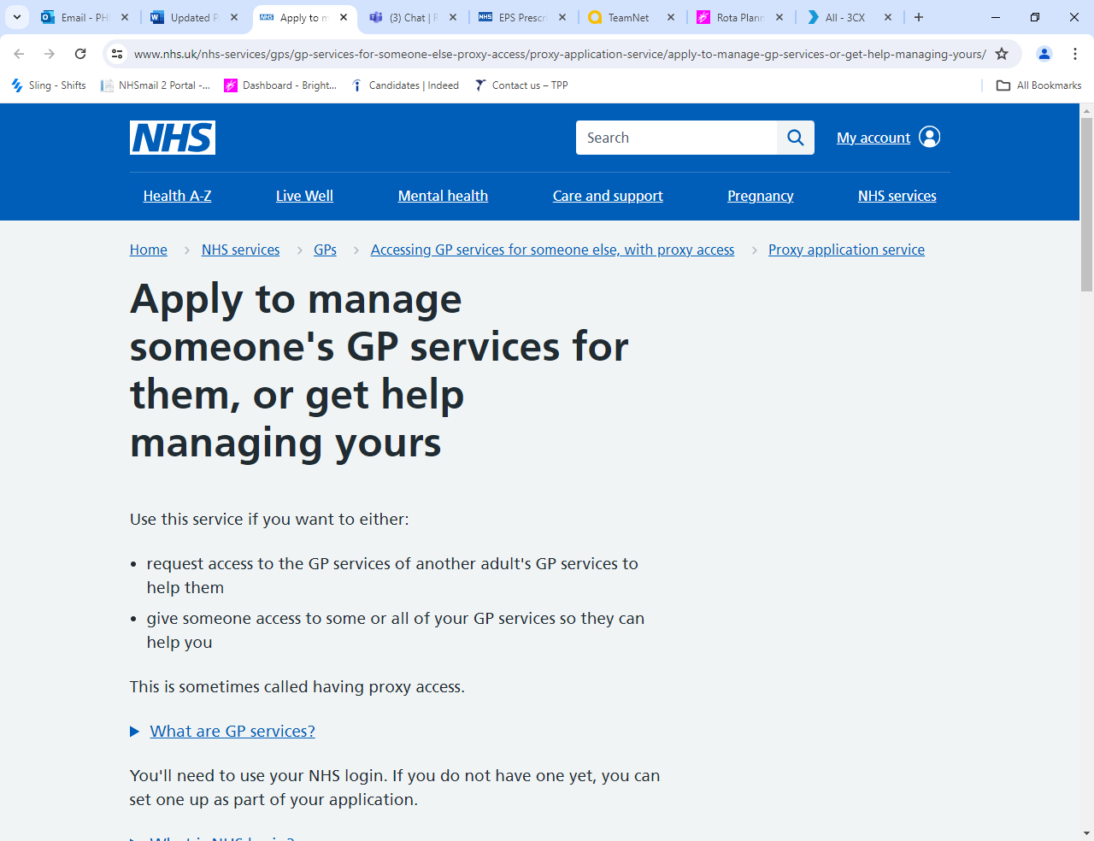

**Prescription requests**

Patients on long term medication can order repeat prescriptions in various ways:

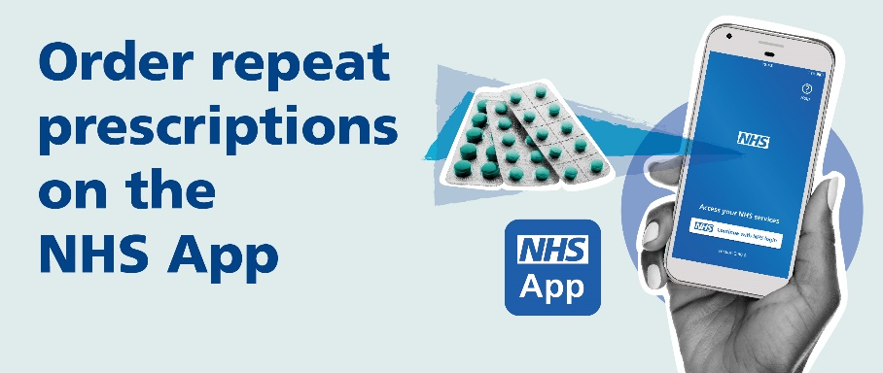

* NHS App – available to request 24/7
* Contact us online - <https://florey.accurx.com/p/D81044>
* 24-hour automated telephone system (please ask reception for a 6-digit passcode). Dial 01223 423424 and follow the prompts.
* Email – [cpicb.nrmcprescriptions@nhs.net](mailto:cpicb.nrmcprescriptions@nhs.net) (please remember to include a name and date of birth for the person who needs the medication)
* By hand – please place your request in the box by the main door
* By post – Send your request to us and include a stamp addressed envelope if you would like your prescription to be returned to you

For reasons of patient safety we are unable to take medication requests over the phone. Taking medication requests over the phone is prone to errors, and for this reason we do not do it. Please do not ask our team to do this for you.

Medication can be requested 10 days in advance of the next issue date (subject to GP approval and not including controlled or high-risk drugs).

Some pharmacies have a service to order on your behalf so please contact your nominated pharmacy to check if they can help you with this.

Please plan ahead for your medication. Requests for repeat prescriptions will take at least 2 full working days (Monday to Friday) for us to deal with it. You must then allow time for your nominated pharmacy to have it ready to collect.

**We follow NHS England guidance, please note we only issue prescriptions for 28 days.**

**Electronic prescriptions**

The practice is set up for the electronic prescription service, which means for most patients we will send your prescription directly to your pharmacy without the need for you to come to the surgery to collect (this excludes private prescriptions which unfortunately can only be printed).

To have your prescriptions sent to your chosen pharmacy please advise a member of the team or alternatively ask your pharmacy to do this for you.

**Medications not on repeat**

If you require mediation that is not on your repeat list, you will need to talk to a GP or our Clinical Pharmacist. Please make an appointment in good time. These medications will also take at least 2 working days to prescribe.

**Medication Reviews**

Patients who have regular repeat medications will need a medication review, usually with either a GP, a Clinical Pharmacist or a nurse practitioner at least once a year to review these medication/s. There may be a delay in receiving your medication if you do not have your medication review. We ask you to respond to the requests from our support team, they are trying to help you manage your medication and help ensure there is not any disruption with your medication.

**Electronic Repeat Dispensing**

If you are stable on routine medication you may be able to benefit from using the Electronic Repeat Dispensing Service (eRD) this means you won’t need to re-order your medication every month.

Please see this link for more information: [**REPEAT DISPENSING - More Information**](https://www.nhsbsa.nhs.uk/pharmacies-gp-practices-and-appliance-contractors/prescribing-and-dispensing/electronic-repeat-dispensing-erd/erd-information-patients)

If you would like further information, please contact us and we can discuss the suitability of this with you.

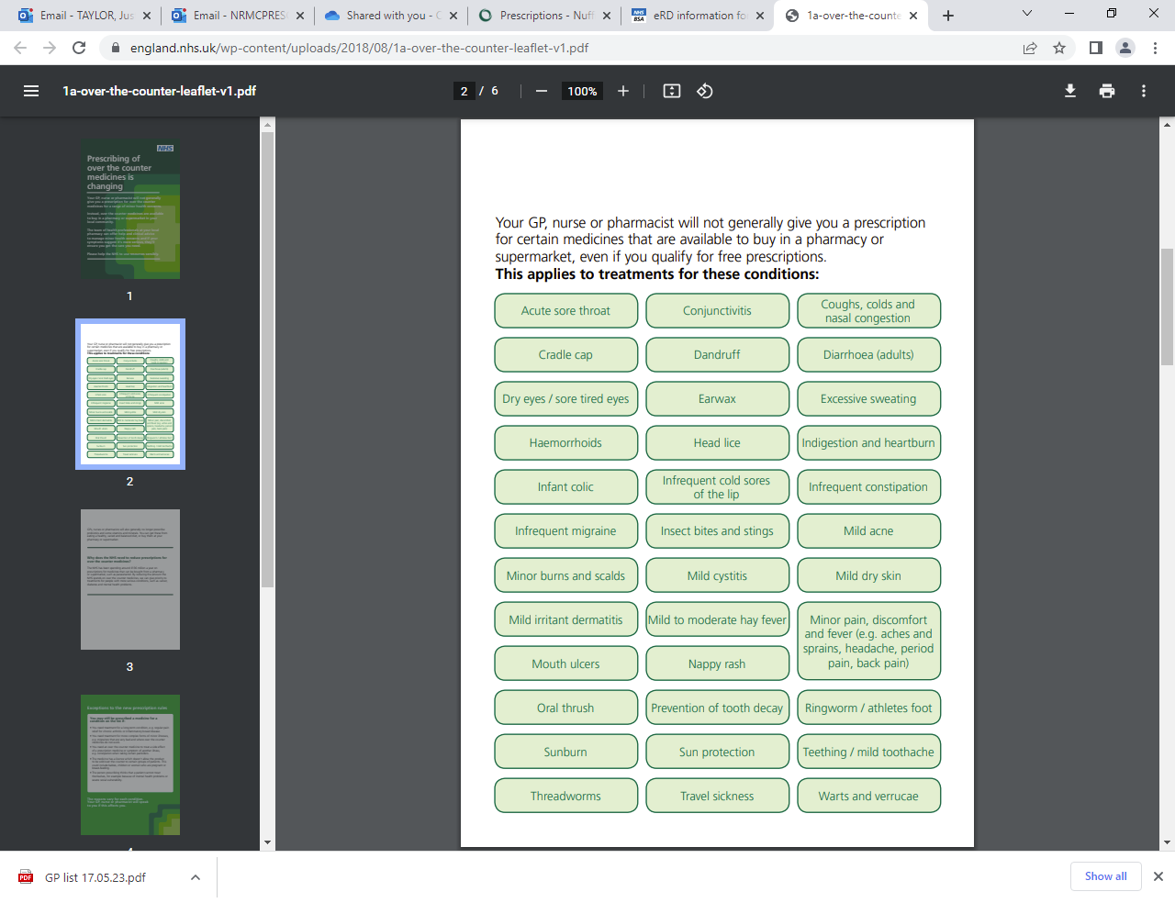**Medications no longer available on the NHS**

**Appointments**

**Long Term Condition Reviews**

If you have a long term condition e.g. Diabetes, Asthma, Heart conditions etc you will be invited for a Long Term Condition review.

The aim of this review is to make sure your condition is being controlled as well as possible and to identify any areas where we can make changes to help you. These may be changes to the type or dosage of medication and check any equipment you might use e.g. inhalers are working effectively. It is also an opportunity to ask any questions about your condition.

Invitations are sent to you in the month before or in your birth month for your initial check. These are known as pre checks. If you do not receive an invitation during your birth month then you can call the LTC clinic coordinators directly on 01223 422588 also by SMS, email, or post. Please do not use this phone number for any other purpose.

When you receive your invite, you can book this appointment by following the link on the invite you receive or by calling direct on 01223 422588.

For some conditions you will be invited to a pre-check appointment. After your pre-check appointment our clinic co-ordinators will arrange a follow up appointment if needed with either a doctor, diabetic or respiratory nurse or clinical pharmacist.

**6–8-Week Baby Check and Post-Natal appointments with a GP and 1st vaccinations for baby**

Once your new baby/babies have been registered with us, you and your baby will be invited in for a 6-8-week baby health check and a postnatal check for mothers.

We ask that you register your new baby/babies as soon as possible after birth (even if you haven’t yet registered the birth with the Registry Office).

The baby check will include a thorough physical examination. This is usually done by a GP. Your baby’s eye’s, heart, hips and for boys, testicles will be checked. They will also have their weight, length and head circumference measured.

The post check for mothers is to make sure you feel well and are recovering properly and to discuss any concerns.

We will also offer to book your baby’s 1st immunisation/vaccination appointment. Your baby can have the vaccinations from 8 weeks old. If you have any concerns regarding vaccinations, this can be discussed either with your health visitor or the GP in your baby check appointment or with one of our practice nurses.

If your child has had some immunisations outside of the UK, please bring relevant records.

**Chaperone**

All patients may have a chaperone present for any consultation, examination or procedure where they feel one is required. The doctor may also request to have a chaperone present.

Before any examination is preformed you will be asked if you would like a chaperone present. If you would a member of the practice team will be asked to enter the room for the duration of the examination. The member of the team who comes in to the room is trained as a chaperone.

A friend or relative may also accompany you as an informal chaperone if preferred.

**Onward Referrals**

**Referral Process - NHS**

As part of your consultation, the clinician may need to make a referral to another service. Once the clinical decision has been made to refer to a service/speciality, be it community or hospital, the referral can take several days to initiate.

The appointment may be either face to face, telephone call, video link etc. this will depend on the service/specialty. It can take several weeks/months before you hear about an appointment for your referral.

The Surgery will inform you that you have been referred and will provide a contact number to follow up the referral. Please do not contact the surgery to follow-up the referral, we are unable to advise further on the referral once it has been done.

**Referral Process – Private**

If you have decided to have a Private referral, either let the clinician know during your appointment, or just give our support team a call. If the clinician has informed you that a referral is needed a further appointment is not required to enable us to provide you with the information you need. However, if the clinician is not aware of the reason for the referral, you will need to see a clinician.

Please note, it can take up to 30 days for the private referral form or letter to be done. Please give us plenty of time to complete the information.

**Self**-**Referral Services**

You can self-refer to some service:

* **Physiotherapy** **-** [**https://www.eoemskservice.nhs.uk/physiotherapy-self-referral** or 0300 555 0123](https://www.eoemskservice.nhs.uk/physiotherapy-self-referral%20or%200300%20555%200123)
* **Weight management – Healthy You -** [**https://healthyyou.org.uk/services/healthy-weight/**](https://healthyyou.org.uk/services/healthy-weight/)
* **Alcohol Reduction – Healthy You -** [**https://healthyyou.org.uk/services/alcohol-reduction/**](https://healthyyou.org.uk/services/alcohol-reduction/)
* **Stop Smoking – Healthy You. Appointments are also available at the surgery for Stop Smoking support – please ask one of the team -** [**https://healthyyou.org.uk/services/stop-smoking/**](https://healthyyou.org.uk/services/stop-smoking/)
* **Sleep Improvement** - Sleepstation [**https://www.sleepstation.org.uk/**](https://www.sleepstation.org.uk/)or [0333 800 9404](tel:0333%20800%209404)
* **Drug and Alcohol service - Change Grow Live (CGL) –** [**https://www.changegrowlive.org/drug-alcohol-service-cambridgeshire/cambridge**](https://www.changegrowlive.org/drug-alcohol-service-cambridgeshire/cambridge)
* **Mental Health Trainer – Healthy You -** [**https://healthyyou.org.uk/services/mental-health-health-trainer/**](https://healthyyou.org.uk/services/mental-health-health-trainer/)

Also, HAY Cambridge has a range of information about support and services available - <https://haycambspboro.co.uk/>

**Non-NHS work**

There are some services that are not part of the services provided by the NHS. This is usually known as non-NHS work. It is usually letters and the completion of forms that are non-NHS work.

**Letters – fees if you require a letter**

Our doctors are frequently asked to provide private or ‘To whom it may concern’ letters and reports for third parties. The standard fee for this is £30.00, payable in advance. More complicated letters and reports may attract a higher fee. Details of the fees for non-nhs work is available on our website <https://www.nrmc.nhs.uk/non-nhs-services>

**Why do I have to pay?**

The preparation of these letters or reports is not covered by the NHS. The doctors must complete them in their own time and as such there is a fee payable. All letters require the doctor to take time to review a patient’s medical records to ensure that the information provided is correct.

‘**How long will it take?’**  
Private letters do not take priority over NHS work, and we will try and complete any requests as soon as possible but please allow at least 30 days.

**‘Which requests will not be done?’**

* **Housing Requests** – We do not provide letters for housing. If the council/housing company are unable to process your application and need further information, they should write to your doctor in confidence and request your written consent for your doctor to provide the information. They will be charged for this.
* **Benefits and PIP** – We do not provide letters for PIP claims. Once you have returned your application to them, they will write directly to us if they require any additional medical information.
* **Letters** **for absence from school or college** - GPs do not provide sick notes for school children. When children are absent from school owing to illness schools may request a letter from the parent or guardian who holds the responsibility of excusing their children from school.
* **Capacity Assessments** - Legal capacity assessments do not fall within the NHS duties of GPs. There are other professionals who can perform mental capacity assessments including solicitors and psychiatrists.

As a surgery we do not feel we have the capacity to offer mental capacity assessments for legal purposes for our patients. To do so would require significant resources being diverted from our core duties as a health care provider.

* **‘Fit to’ Letters** - We do not provide letters for fit to fly/travel or participation activities e.g. running events.
* **Certifying Identification Documents** - We do not provide this service for documents such as passports and visas and other documents that require certification of a similar nature.

**Registering a Death**

It can be a confusing time following the death of a loved one and difficult to know what you need to do first, especially if this is the first time you are experiencing it. There are many practical issues to manage, and we hope the following information will assist you at this difficult time.

All deaths occurring in England must normally be registered by a Registrar of Births, Death and Marriages within 5 days of their occurrence, unless the coroner is involved.

The duty to provide the particulars for registration rests principally with a relative of the deceased, but if no such relative is available, the duty may be performed by any person present at the death, or the deceased’s Executor or other Representative, or the Occupier of the premises where the death took place.

Registration must normally take place in the office of the Registrar for the registration district in which the death took place.

If you are unsure whether you can register the death, you should telephone the Registrar’s Office for advice: 0345 045 1363

To Book an Appointment online please visit: - [www.cambridgeshire.gov.uk/residents/births-deaths-and-marriages/deaths/registering-a-death](http://www.cambridgeshire.gov.uk/residents/births-deaths-and-marriages/deaths/registering-a-death)

Location:

Cambridgeshire County Council

Ascham Road

Cambridge

CB4 2BD

**Information Required for Registration**

The Registrar will see you in private to ask for details about the deceased. You will need to provide the following information about the deceased: -

* The person's full name at time of death and any names previously used, including maiden surname
* The person's date and place of birth (town and county if born in the UK and country if born abroad)
* Their last address
* Their occupation
* The full name, date of birth and occupation of a surviving spouse or civil partner
* If they were getting a state pension or any other state benefit

**Issuing the Death Certificate**

Nuffield Road Medical Centre will issue a Death Certificate in conjunction with the Medical Examiner Officer. Once the Death Certificate has been completed by the doctor, the Medical Examiner Officer will give you a telephone call to discuss. The Medical Examiner Officer will forward the Death Certificate to the Cambridge Registrar. You are not required to collect the Death Certificate from the surgery.

If the death has been referred to the Coroner, the Coroner’s Officer will contact and advise you of the next steps, and the Coroner’s Officer will forward the Death Certificate to the Cambridge Registrar.

**Respect for the practice staff**

The practice staff will always show respect & courtesy when dealing with patients and representatives. We respectfully request patients, and their representatives will do the same when dealing with members of the practise. No form of aggression verbal or physical will be tolerated, in any instant of suggest behaviour on practice premises may results in being reported to the police & removed from the practice’s registered list.

**Compliments, Feedback and Complaints**

Please help us to get it right. Our aim is to provide patients and carers with excellent care and outstanding service.

Your feedback is key to improving the service provided. Please contact the Practice Manager by telephone or if you prefer in writing. Every effort will be made to answer your concerns as soon as possible. This will either be by the Practice Manager, or one of the team, as appropriate.

We are always keen to hear of ways in which we can improve our care for patients. Comments and suggestions can be made in writing to us via email [cpicb.nrmcpatients@nhs.net](mailto:cpicb.nrmcpatients@nhs.net)

If you feel that our services have failed to meet your needs, please do let us know. Our Practice Manager is available to discuss any concerns or problems. If however, you wish to make a formal complaint, again please send an email to the above address. We strive to deal with all complaints in a quick, efficient manner. Our complaints information is available [here](https://www.nrmc.nhs.uk/leave-feedback).

If you consider the matter cannot be dealt with by the surgery, or you have tried to resolve the matter at the surgery, you can contact the Patient Experience Team at Cambridgeshire and Peterborough Integrated Care Services. More details are available [here](https://www.cpics.org.uk/patient-experience-team/#:~:text=You%20can%20contact%20the%20Patient,.pet%40nhs.net.).

**When the surgery is closed**

For non-urgent medical attention when the surgery does not have capacity or closed, please contact 111 to be directed to the out of hour’s services.

Accident and Emergency please either go to A and E or call 999 for an ambulance if you have a real Critical and life-threatening emergency.

Minor injury’s local clinic is in Ely, CB6 1DN can treat injuries that are not critical or life-threatening. You may wish to consider attending a Minor Injuries Unit if it is suitable for the type of injury that you have.

**Other health care services**

If you are feeling unwell, please choose the appropriate service. It may not be the surgery that is the most appropriate place for support.

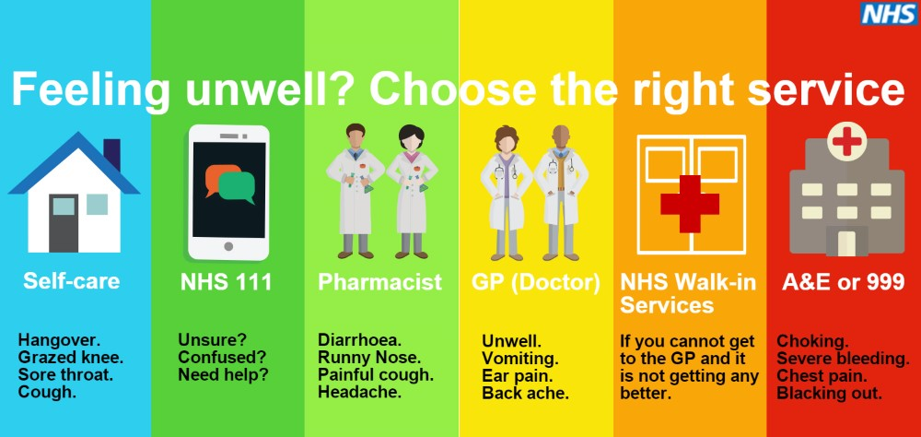

**Other health care service telephone numbers;**

* Midwife Team (Ivy team) – 01223 348981 or urgent advice line 01223 217217
* Children Centre and Health Visitors01223 728118 and 03000295050
* District Nurses- 01223 726469 or after 5pm 03307260077
* Adult’s Social Care - 0345 0455202
* Ely Minor Injury Unit - 01353 656675