Nuffield Road Medical Centre
Patient Booklet

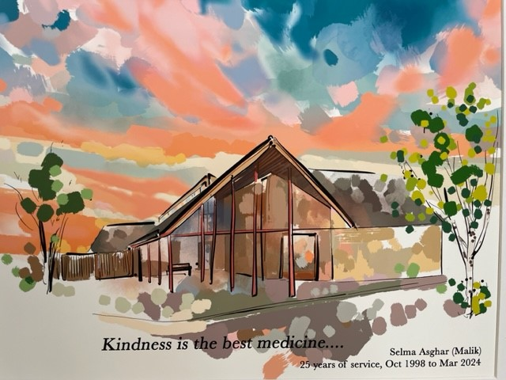

ROAD MEDICAL CENTER.
Nuffield Road Medical Centre
10 Pippin Drive
Cambridge
Cambridgeshire
CB4 1GL

Telephone - 01223 423424
Website - www.nrmc.nhs.uk/homepage

Welcome

Welcome to Nuffield Road Medical Centre.
The Partners and team would like to welcome you to Nuffield Road Medical Centre. We hope you find lots of useful information about the surgery and the services we offer on our website and this introductory guide.
Our aim is to provide excellent and high quality personal care to all our patients, whilst respecting confidentiality and patient dignity. We strive to deliver a professional patient focused service and always encourage patients to be involved in the planning and maintenance of their own health and well-being.
We are a friendly team with 25 clinical staff and an experienced team of support staff.
By joining Nuffield Road Medical Centre, you have agreed to work in partnership with us as your NHS health care provider. The success of our partnership relies on both parties understanding the needs of each other, maintaining good co-operation and communication.
Our responsibility to you:
- You will be treated with dignity and respect at all times
- You have the right to confidentiality
- You have the right to access your medical records, subject to the limitation of the law
- You will receive the results of any tests or investigations once we have them
- Your suggestions, concerns, complaints and compliments will be welcomed and used where possible to drive improvement
Your responsibility to us:
- We expect all staff to be treated with the same respect you would want to receive from us. We have a zero tolerance policy with regards to abuse.
- You will inform us if you are unable to attend an appointment
- You will inform us of any changes to your personal details, including a change of address
When booking an appointment at the surgery, you will be directed to the most appropriate clinician; this may not be a GP. We ask that you provide our support team with sufficient information to enable them to direct you appropriately. Unfortunately due to the ongoing underfunding in the NHS, at this time it is not possible for everyone to see a GP. All our clinicians are experienced. Thank you for your understanding.
We hope you find the booklet helpful. If you need anything further, please do not hesitate to ask a member of the team. Once, again, your feedback is welcome.

Best wishes, The Partners and Practice Manager, Nuffield Road Medical Centre

Contents
Welcome Page 2
Kindness is the best medicine Page 3
About our team Page 5
Registering at the surgery Page 7
Registering at the surgery – out of area Page 7
New baby registrations Page 8
Change of details Page 8
Booking appointments Page 9
Attending appointments Page 9
Extended hours appointments Page 9
Home visit Page 10
Waiting list Page 10
Cancelling an appointment Page 10
Blood results / test results Page 10
Administration / Prescriptions other queries Page 11
Access to your medical record Page 12
Proxy access (giving access to your medical record) Page 12
Prescription requests Page 13
Electronic prescriptions Page 14
Medications not on repeat prescription Page 15
Medication reviews Page 15
Electronic repeat dispensing Page 15
Medications no longer available on the NHS Page 15
Appointments – Long Term Condition Reviews Page 16
6-8 week baby checks and post-natal appointments Page 16
Chaperone Page 17
Referrals to other services Page 18
Self Referral Services Page 19
Non-NHS work Page 20
Letters and fees Page 21
Registering a death Page 22
Respect and behavior Page 24
Compliments, Feedback and Complaints Page 24
When the surgery is closed Page 25

Kindness is the best medicine …

The practice serves the area in Cambridge City lying to the North and West of the river and the villages of Histon, Impington and Milton. Our practice area is available here:
https://www.nrmc.nhs.uk/register-at-the-practice
We welcome you choosing Nuffield Road Medical Centre to support you with your health needs.
We ask that everyone is treated with respect. We do not tolerate any aggressive, violent or discriminatory behavior towards our team. We have a zero-tolerance of behavior of this nature. The practice will use its right to remove patients from our list with immediate effect, to safeguard the team, patients and other members of the public.

About our team
Our Practice Manager is Pipla Dewan
Pipla can be contacted at cpicb.nrmcpatients@nhs.net

GP Partners at the practice are:

Dr Mark Brookes Dr Sarayu Nair
Dr Annabel Wood Dr Katherine Wyatt

Registrars
Emily Robinson
Yusuf Ak
Theresa Chara – Clinical Pharmacist
James Gatton, Angus Taylor and Veedika Marwah – First Contact Practitioner
Advanced Care Team
Raj Sharma – Advanced Care Practitioner
Dharamendra Nortam – Emergency Care Practitioner
Lydia Chinyere – Advanced Nurse Practitioner (Diabetes)
Kat Burrell – Advanced Nurse Practitioner (Respiratory)
Doctors
Dr Claire Charlesworth
Dr Paula Garzon
Dr Vikki Hobbs
Dr Samira Hoque
Dr Nadia Jawed
Dr Christine Kerr
Dr Yen Xuan Nguyen
Dr Keiko Verzon

Nursing / Health Care Assistant (HCA) Team
Lead Nurse – Sarah Vatcher HCA – Mandy Burling
Nurse – Swati Jain HCA – Glenda Campbell
Nurse – Callie Hewkin HCA – Marie Gilbert

Elisabet Lajara – Social Prescriber

The team are supported by a skilled support team. These roles include reception, administration, prescription clerks and care co-ordinators.

We have a multi-disciplinary team to support our patients.

Advanced Nurse Practitioner - Fully qualified who deal with minor illnesses
Emergency Care Practitioner – Trained in nursing and paramedic skills. Work alongside our clinical team to help manage routine and urgent appointments, and attends home visits.

First Contact Practitioner (FCP) - First contact practitioners in primary care are to assess patients with muscle, soft tissues and joint pain to help decide on the most appropriate management, for example;
All soft tissue, sprains, strains or sports injuries.
Arthritis – any joint
Spinal related pain in arms or legs. Nerve pain such as pins and needles or numbness.
Spinal pain including lower back/ mid back and neck pain.
Please note FCP’s cannot see anyone under the age of 16, or someone who needs medical management of rheumatoid conditions or house-bound patients.

Health Care Assistants can offer
Long term pre-checks Blood testing ECG
Blood pressure check New patient check Weight checks

If a child is needing a blood test and they are under the age of 10, you will need to collect a blood form from the GP or Receptionist and attend an appointment at the hospital.

Nurses can offer
Cervical smear screening Smoking cessation Diabetic clinic
Baby & child immunisations Minor injury check Contraception pill review
Travel advice & immunisations

Social Prescriber - We have a social prescriber who is here to help with any worries or advise with regards to financial issues, letter requests, help with wanting to join social groups etc.

New Patient Registrations
If you live within our practice area and wish to register with us, you can register online or using the new registration forms.
Using our online form is the quickest and easiest way to register with the surgery. If you use the online link below, registration is usually completed within 2 working days. To do this, please use this link: https://register-with-gp.ht1.uk/?gpCode=D81044&gpName=Nuffield%20Road%20Medical%20Centre

How to Register at the Practice
If you prefer to use the paper forms, these can be found on our website using the following link: https://www.nrmc.nhs.uk/register-at-the-practice
If you complete the paper form, registration will be completed within 7 working days.
The forms can also be collected from the reception.
When we receive your registration you will be asked to a new patient health check with a Health Care Assistant. We encourage all our new patients to attend this appointment.
Once we have accepted your registration your medical records will be transferred to the practice.
Out of Area Registrations
If you live outside of the practice area we are unable to accept a registration.
If you change your address to outside of our practice area you will be asked to re-register at a surgery closer to your new home. You will be given 30 days to do this. After this time you will be taken off the register at the surgery.

New Baby Registrations
We encourage you to register your baby with a GP as soon as possible. You do not have to wait until you have registered the birth with the Registry Office. This helps in case urgent care is required and enables us to book in their 6–8-week baby check and inoculations. You will need to complete a GMS1 form and a New Patient Questionnaire. We ask that at least one parent is already registered with the surgery or registers at the same time.

Change of Details
If you change your address, email address, telephone number, mobile number or next of kin please inform us as soon as possible. It is important to keep your contact details up to date in case we need to contact you or a family member in an emergency.
If you wish to amend your name on your medical record, we will need to see some form of photo ID. This can be done on our website by clicking on ‘submit a new request’.

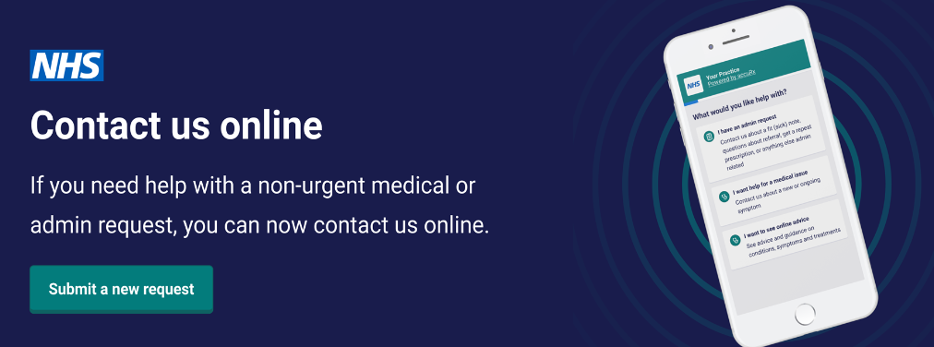

Booking appointments
Triage system, we no longer book GP appointments over the phone. We are asking our patients to contact the surgery by completing an online consultation form on our website.
This will be used for both routine and urgent appointments with the doctors, prescription requests, sick notes, test results, reports and letters.
All the requests will be reviewed by the doctors on the same day to ensure they are managed appropriately and you will receive a response in a timely manner.
If you do not know how to use the internet or have no access, you will still be able to contact us on 01223 423424 and a member of the team will complete the online form for you on your behalf. We encourage the patients to try this if you have access as it helps get better requests from the patient regarding more information to then help your request be triaged correctly.
The duty doctor will triage your request and advise the support team on where to book your appointment, this could be with a GP, Nurse, Physiotherapist, Advanced Care Practitioner or even referred to a local pharmacy.
Your appointment could be triaged as urgent, been seen within a week or routine (average 2 weeks) with a GP.
Telephone – Our phoneline is open during the hours of 8.30am until 6pm Monday to Friday. 01223 423424
Call backs – Call backs is a recently new facility, call 01223 423424, press option 2. You will then be asked if you would like to request a call back. Once your call back has been logged you can hang up the phone and the system will call you back automatically once a receptionist becomes available. (You will keep your position in the queue).
We understand it is preferable for you to see your usual doctor whenever you can. However, if your problem is urgent and your doctor is not available, our reception team will explain what alternatives are available.
Demand at the moment for general practice is very high, therefore we will do our best to get you seen as soon as you can. Please be kind to our team.
Attending appointments
We would ask patients to arrive on time to any appointment to ensure proper use of availability and resources. We offer different ways of attending an appointment with a clinician such as face to face, telephone consultations or video call.
Some times our clinicians do run late. We ask for your understanding, as our clinicians want to ensure that they give patients time that is needed. Our reception team will try and keep you updated. If you are concerned about the time you are waiting, please talk to our receptionist.
To help you get the best out of your appointment, please see our guidance on the website. Information can be found here –

Extended hours appointments
We do have an Extended Access service. We work in Partnership with PCN to provide this service. We can book these appointments, and the appointments are available on Saturday and Tuesday, Wednesday and Thursday evening. They offer Clinicians, Nurses and Healthcare Assistants appointments. These appointments can be at various locations around Cambridge.
Home Visits
If you, the patient is housebound or request a home visit, please call the surgery. Please provide the support team with sufficient details to enable the GP to assess the urgency of the home visit. The GP will confirm a home visit and which clinician may attend. This will not be a GP.
Cancelling an appointment
Unfortunately, about 10% of our appointments are wasted every month. This is due to our patients not cancelling appointments. It is very important to inform reception as soon as possible if you are not able to attend your appointment so we can offer the appointment to another patient.
You can cancel your appointment in three ways:
- Call our cancellation number - 01223 422545. Please leave a voicemail with your name, date of birth and the date and time of the appointment you would like to cancel.
- If you are not able to call, then please send a message on our website using the following link - https://florey.accurx.com/p/D81044

Blood results / test results / prescriptions and other enquiries
To help us deal with the calls first thing in the morning for appointments, we ask that if you are calling regarding results, prescriptions, admin queries please call after 2pm.
Unfortunately if you do call before 2pm, we will be unable to deal with your query and you will be asked to call back after 2pm.

Administration / Prescribing / other queries
- Requests using the link on our website
You can send a message to us on our website to request a medical appointment, order medications and request admin queries; by clicking on the following:

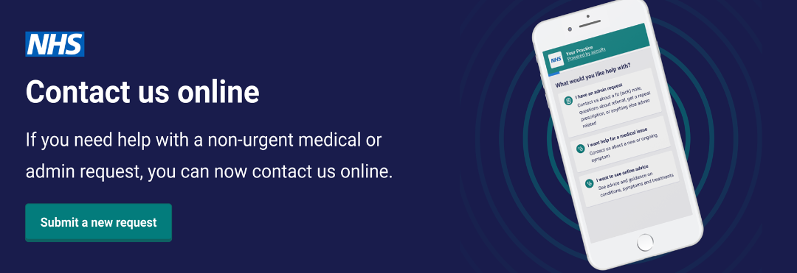

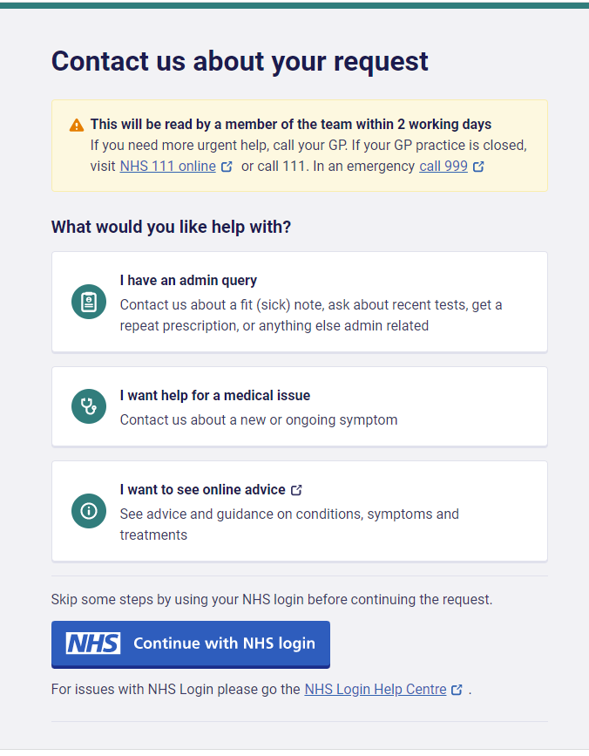

Once this has been filled out, the request will be sent to our support team, and they will contact you within 2 working days.

Access to your medical record
Where it is safe for you to do so, we encourage you to have access to your medical records.
The easiest way to do this is by downloading the NHS App. Once you download the NHS App, you will be able to see your medical records from that date onwards. More information about the NHS App are below.

Alternatively, you can be given access via the airmid app. More information is provided below.
The benefits of having access to your medical record are:
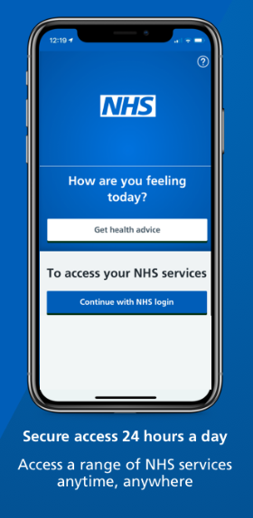
On occasions, your GP may consider it unsafe for you to have access to your medical record. Should this be the case, you will have the opportunity to discuss this with the Practice Manager or your GP.

NHS App
You can also access your account through the NHS app. The team will need to give you full clinical access first to view your records and then once you receive that, then you can create your own account to book appointments, order medications, view your records and test results etc.

Proxy Access
We provide proxy online access to patients who may require their family or friends to help them order medications, book appointments and view your medical records. Also, if you have younger children, you can attach their records to yours so you can again book appointments and anything that you require.
Please click the link below to be able to register for an online proxy account:
PROXY ACCESS - More Information – once you click the link, it will take you to the page shown below.

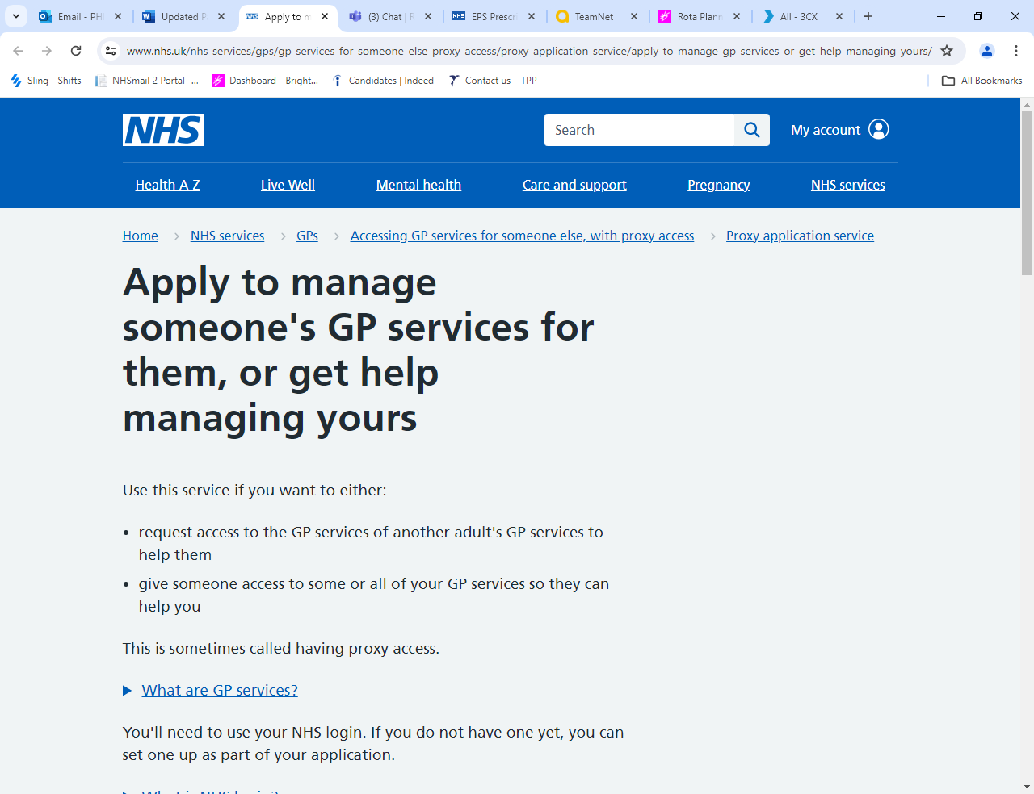

Prescription requests
Patients on long term medication can order repeat prescriptions in various ways:
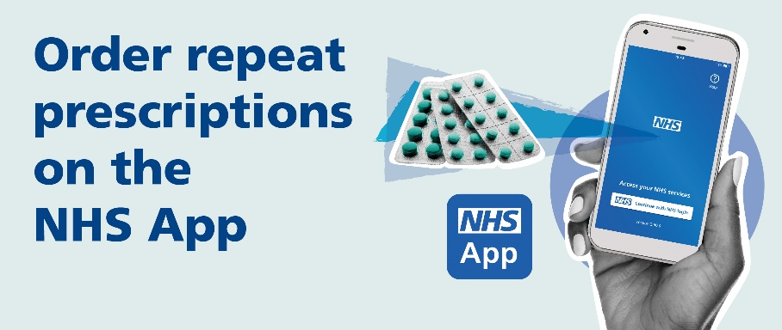

- NHS App – available to request 24/7
- Contact us online - https://florey.accurx.com/p/D81044
- 24-hour automated telephone system (please ask reception for a 6-digit passcode). Dial 01223 423424 and follow the prompts.
- Email – cpicb.nrmcprescriptions@nhs.net (please remember to include a name and date of birth for the person who needs the medication)
- By hand – please place your request in the box by the main door
- By post – Send your request to us and include a stamp addressed envelope if you would like your prescription to be returned to you
For reasons of patient safety we are unable to take medication requests over the phone. Taking medication requests over the phone is prone to errors, and for this reason we do not do it. Please do not ask our team to do this for you.
Medication can be requested 10 days in advance of the next issue date (subject to GP approval and not including controlled or high-risk drugs).
Some pharmacies have a service to order on your behalf so please contact your nominated pharmacy to check if they can help you with this.
Please plan ahead for your medication. Requests for repeat prescriptions will take at least 2 full working days (Monday to Friday) for us to deal with it. You must then allow time for your nominated pharmacy to have it ready to collect.
We follow NHS England guidance, please note we only issue prescriptions for 28 days.

Electronic prescriptions
The practice is set up for the electronic prescription service, which means for most patients we will send your prescription directly to your pharmacy without the need for you to come to the surgery to collect (this excludes private prescriptions which unfortunately can only be printed).
To have your prescriptions sent to your chosen pharmacy please advise a member of the team or alternatively ask your pharmacy to do this for you.

Medications not on repeat
If you require mediation that is not on your repeat list, you will need to talk to a GP or our Clinical Pharmacist. Please make an appointment in good time. These medications will also take at least 2 working days to prescribe.

Medication Reviews
Patients who have regular repeat medications will need a medication review, usually with either a GP, a Clinical Pharmacist or a nurse practitioner at least once a year to review these medication/s. There may be a delay in receiving your medication if you do not have your medication review. We ask you to respond to the requests from our support team, they are trying to help you manage your medication and help ensure there is not any disruption with your medication.

Electronic Repeat Dispensing
If you are stable on routine medication you may be able to benefit from using the Electronic Repeat Dispensing Service (eRD) this means you won’t need to re-order your medication every month.
Please see this link for more information: REPEAT DISPENSING - More Information
If you would like further information, please contact us and we can discuss the suitability of this with you.

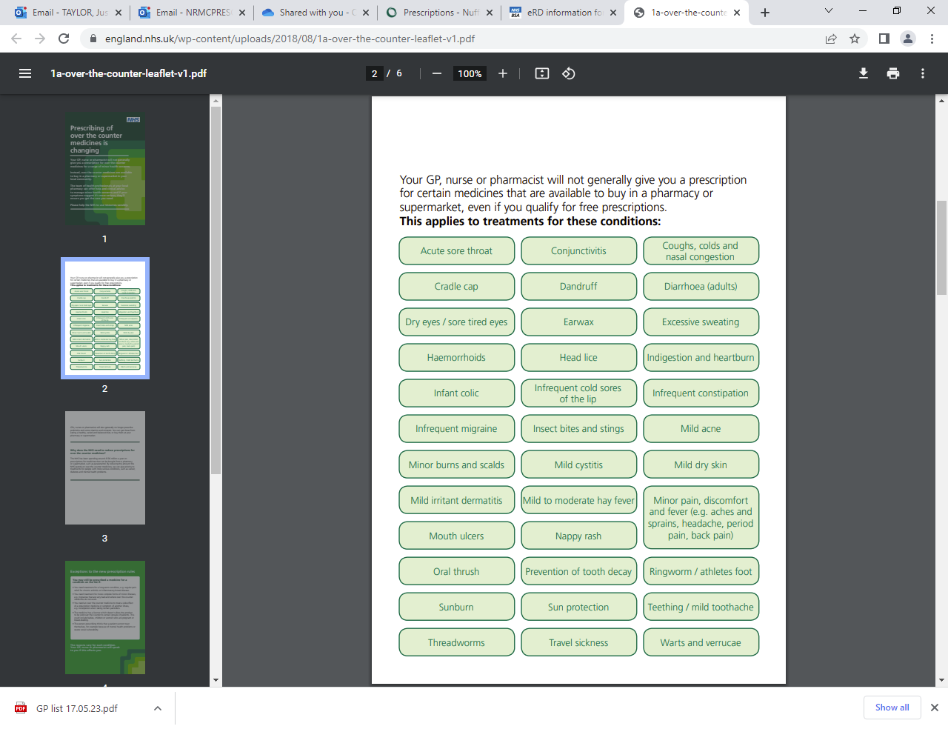
Medications no longer available on the NHS

Appointments
Long Term Condition Reviews
If you have a long term condition e.g. Diabetes, Asthma, Heart conditions etc you will be invited for a Long Term Condition review.
The aim of this review is to make sure your condition is being controlled as well as possible and to identify any areas where we can make changes to help you. These may be changes to the type or dosage of medication and check any equipment you might use e.g. inhalers are working effectively. It is also an opportunity to ask any questions about your condition.
Invitations are sent to you in the month before or in your birth month for your initial check. These are known as pre checks. If you do not receive an invitation during your birth month then you can call the LTC clinic coordinators directly on 01223 422588 also by SMS, email, or post. Please do not use this phone number for any other purpose.
When you receive your invite, you can book this appointment by following the link on the invite you receive or by calling direct on 01223 422588.
For some conditions you will be invited to a pre-check appointment. After your pre-check appointment our clinic co-ordinators will arrange a follow up appointment if needed with either a doctor, diabetic or respiratory nurse or clinical pharmacist.

6–8-Week Baby Check and Post-Natal appointments with a GP and 1st vaccinations for baby
Once your new baby/babies have been registered with us, you and your baby will be invited in for a 6-8-week baby health check and a postnatal check for mothers.
We ask that you register your new baby/babies as soon as possible after birth (even if you haven’t yet registered the birth with the Registry Office).
The baby check will include a thorough physical examination. This is usually done by a GP. Your baby’s eye’s, heart, hips and for boys, testicles will be checked. They will also have their weight, length and head circumference measured.
The post check for mothers is to make sure you feel well and are recovering properly and to discuss any concerns.
We will also offer to book your baby’s 1st immunisation/vaccination appointment. Your baby can have the vaccinations from 8 weeks old. If you have any concerns regarding vaccinations, this can be discussed either with your health visitor or the GP in your baby check appointment or with one of our practice nurses.
If your child has had some immunisations outside of the UK, please bring relevant records.

Chaperone
All patients may have a chaperone present for any consultation, examination or procedure where they feel one is required. The doctor may also request to have a chaperone present.
Before any examination is preformed you will be asked if you would like a chaperone present. If you would a member of the practice team will be asked to enter the room for the duration of the examination. The member of the team who comes in to the room is trained as a chaperone.
A friend or relative may also accompany you as an informal chaperone if preferred.

Onward Referrals
Referral Process - NHS
As part of your consultation, the clinician may need to make a referral to another service. Once the clinical decision has been made to refer to a service/speciality, be it community or hospital, the referral can take several days to initiate.
The appointment may be either face to face, telephone call, video link etc. this will depend on the service/specialty. It can take several weeks/months before you hear about an appointment for your referral.
The Surgery will inform you that you have been referred and will provide a contact number to follow up the referral. Please do not contact the surgery to follow-up the referral, we are unable to advise further on the referral once it has been done.

Referral Process – Private
If you have decided to have a Private referral, either let the clinician know during your appointment, or just give our support team a call. If the clinician has informed you that a referral is needed a further appointment is not required to enable us to provide you with the information you need. However, if the clinician is not aware of the reason for the referral, you will need to see a clinician.
Please note, it can take up to 30 days for the private referral form or letter to be done. Please give us plenty of time to complete the information.

Self-Referral Services
You can self-refer to some service:
- Physiotherapy - https://www.eoemskservice.nhs.uk/physiotherapy-self-referral or 0300 555 0123
- Weight management – Healthy You - https://healthyyou.org.uk/services/healthy-weight/
- Alcohol Reduction – Healthy You - https://healthyyou.org.uk/services/alcohol-reduction/
- Stop Smoking – Healthy You- Self referral at https://healthyyou.org.uk/services/stop-smoking/
- Sleep Improvement - Sleepstation https://www.sleepstation.org.uk/ or 0333 800 9404
- Drug and Alcohol service - Change Grow Live (CGL) – https://www.changegrowlive.org/drug-alcohol-service-cambridgeshire/cambridge
- Mental Health Trainer – Healthy You - https://healthyyou.org.uk/services/mental-health-health-trainer/
Also, HAY Cambridge has a range of information about support and services available - https://haycambspboro.co.uk/

Non-NHS work
There are some services that are not part of the services provided by the NHS. This is usually known as non-NHS work. It is usually letters and the completion of forms that are non-NHS work.

Letters – fees if you require a letter
Our doctors are frequently asked to provide private or ‘To whom it may concern’ letters and reports for third parties. The standard fee for this is £30.00, payable in advance. More complicated letters and reports may attract a higher fee. Details of the fees for non-nhs work is available on our website https://www.nrmc.nhs.uk/non-nhs-services

Why do I have to pay?
The preparation of these letters or reports is not covered by the NHS. The doctors must complete them in their own time and as such there is a fee payable. All letters require the doctor to take time to review a patient’s medical records to ensure that the information provided is correct.

‘How long will it take?’
Private letters do not take priority over NHS work, and we will try and complete any requests as soon as possible but please allow at least 30 days.

‘Which requests will not be done?’
- Housing Requests – We do not provide letters for housing. If the council/housing company are unable to process your application and need further information, they should write to your doctor in confidence and request your written consent for your doctor to provide the information. They will be charged for this.
- Benefits and PIP – We do not provide letters for PIP claims. Once you have returned your application to them, they will write directly to us if they require any additional medical information.
- Letters for absence from school or college - GPs do not provide sick notes for school children. When children are absent from school owing to illness schools may request a letter from the parent or guardian who holds the responsibility of excusing their children from school.
- Capacity Assessments - Legal capacity assessments do not fall within the NHS duties of GPs. There are other professionals who can perform mental capacity assessments including solicitors and psychiatrists.
As a surgery we do not feel we have the capacity to offer mental capacity assessments for legal purposes for our patients. To do so would require significant resources being diverted from our core duties as a health care provider.
- ‘Fit to’ Letters - We do not provide letters for fit to fly/travel or participation activities e.g. running events.
- Certifying Identification Documents - We do not provide this service for documents such as passports and visas and other documents that require certification of a similar nature.

Registering a Death
It can be a confusing time following the death of a loved one and difficult to know what you need to do first, especially if this is the first time you are experiencing it. There are many practical issues to manage, and we hope the following information will assist you at this difficult time.
All deaths occurring in England must normally be registered by a Registrar of Births, Death and Marriages within 5 days of their occurrence, unless the coroner is involved.
The duty to provide the particulars for registration rests principally with a relative of the deceased, but if no such relative is available, the duty may be performed by any person present at the death, or the deceased’s Executor or other Representative, or the Occupier of the premises where the death took place.
Registration must normally take place in the office of the Registrar for the registration district in which the death took place.
If you are unsure whether you can register the death, you should telephone the Registrar’s Office for advice: 0345 045 1363
To Book an Appointment online please visit: - www.cambridgeshire.gov.uk/residents/births-deaths-and-marriages/deaths/registering-a-death
Location:
Cambridgeshire County Council
Ascham Road
Cambridge
CB4 2BD

Information Required for Registration
The Registrar will see you in private to ask for details about the deceased. You will need to provide the following information about the deceased: -
- The person's full name at time of death and any names previously used, including maiden surname
- The person's date and place of birth (town and county if born in the UK and country if born abroad)
- Their last address
- Their occupation
- The full name, date of birth and occupation of a surviving spouse or civil partner
- If they were getting a state pension or any other state benefit

Issuing the Death Certificate
Nuffield Road Medical Centre will issue a Death Certificate in conjunction with the Medical Examiner Officer. Once the Death Certificate has been completed by the doctor, the Medical Examiner Officer will give you a telephone call to discuss. The Medical Examiner Officer will forward the Death Certificate to the Cambridge Registrar. You are not required to collect the Death Certificate from the surgery.
If the death has been referred to the Coroner, the Coroner’s Officer will contact and advise you of the next steps, and the Coroner’s Officer will forward the Death Certificate to the Cambridge Registrar.

Respect for the practice staff
The practice staff will always show respect & courtesy when dealing with patients and representatives. We respectfully request patients, and their representatives will do the same when dealing with members of the practise. No form of aggression verbal or physical will be tolerated, in any instant of suggest behaviour on practice premises may results in being reported to the police & removed from the practice’s registered list.

Compliments, Feedback and Complaints
Please help us to get it right. Our aim is to provide patients and carers with excellent care and outstanding service.
Your feedback is key to improving the service provided. Please contact the Practice Manager by telephone or if you prefer in writing. Every effort will be made to answer your concerns as soon as possible. This will either be by the Practice Manager, or one of the team, as appropriate.
We are always keen to hear of ways in which we can improve our care for patients. Comments and suggestions can be made in writing to us via email cpicb.nrmcpatients@nhs.net
If you feel that our services have failed to meet your needs, please do let us know. Our Practice Manager is available to discuss any concerns or problems. If however, you wish to make a formal complaint, again please send an email to the above address. We strive to deal with all complaints in a quick, efficient manner. Our complaints information is available here.
If you consider the matter cannot be dealt with by the surgery, or you have tried to resolve the matter at the surgery, you can contact the Patient Experience Team at Cambridgeshire and Peterborough Integrated Care Services. More details are available here.

When the surgery is closed
For non-urgent medical attention when the surgery does not have capacity or closed, please contact 111 to be directed to the out of hour’s services.
Accident and Emergency please either go to A and E or call 999 for an ambulance if you have a real Critical and life-threatening emergency.
Minor injury’s local clinic is in Ely, CB6 1DN can treat injuries that are not critical or life-threatening. You may wish to consider attending a Minor Injuries Unit if it is suitable for the type of injury that you have.

Other health care services
If you are feeling unwell, please choose the appropriate service. It may not be the surgery that is the most appropriate place for support.
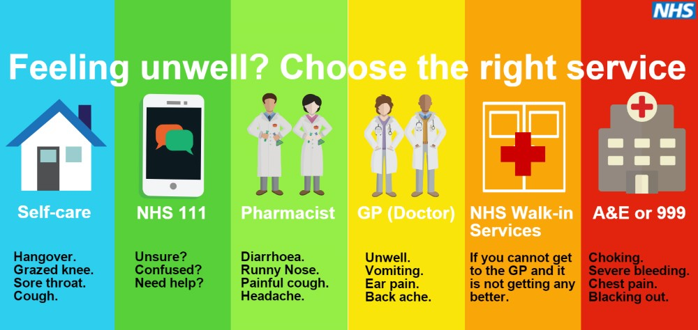

Other health care service telephone numbers;
- Midwife Team (Ivy team) – 01223 348981 or urgent advice line 01223 217217
- Children Centre and Health Visitors 01223 728118 and 03000295050
- District Nurses - 01223 726469 or after 5pm 03307260077
- Adult’s Social Care - 0345 0455202
- Ely Minor Injury Unit - 01353 656675

